EXPERIMENT 2: SECURITY PRINCIPLES

AIM

To understand core security principles like CIA triad, security models, and risk management in cybersecurity.

PROCEDURE

- Study the CIA triad (confidentiality, integrity, availability).
- Understand DAD (disclosure, alteration, denial) and security attacks.
- Learn security models and principles like Defence-in-Depth and Zero Trust.
- Differentiate between vulnerability, threat, and risk.

QUESTIONS

TASK 1 - CIA



TASK 2 - DAD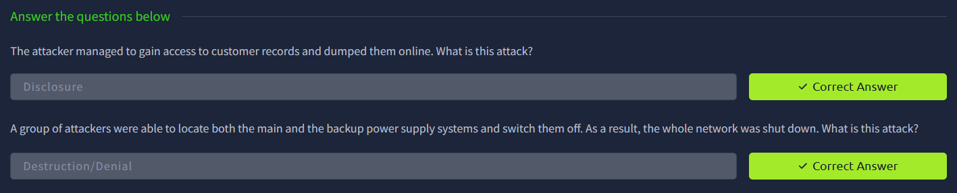

TASK 3 - Fundamental Concepts of Security Models


TASK 4 - ISO/IEC 19249



RESULT

Gained understanding of fundamental security principles and how they are applied to protect systems and data.

